Power Electronics Laboratory: Experiment 3

Name: Rushali Chakraborty

Roll no.: 19EE3FP28

(1)

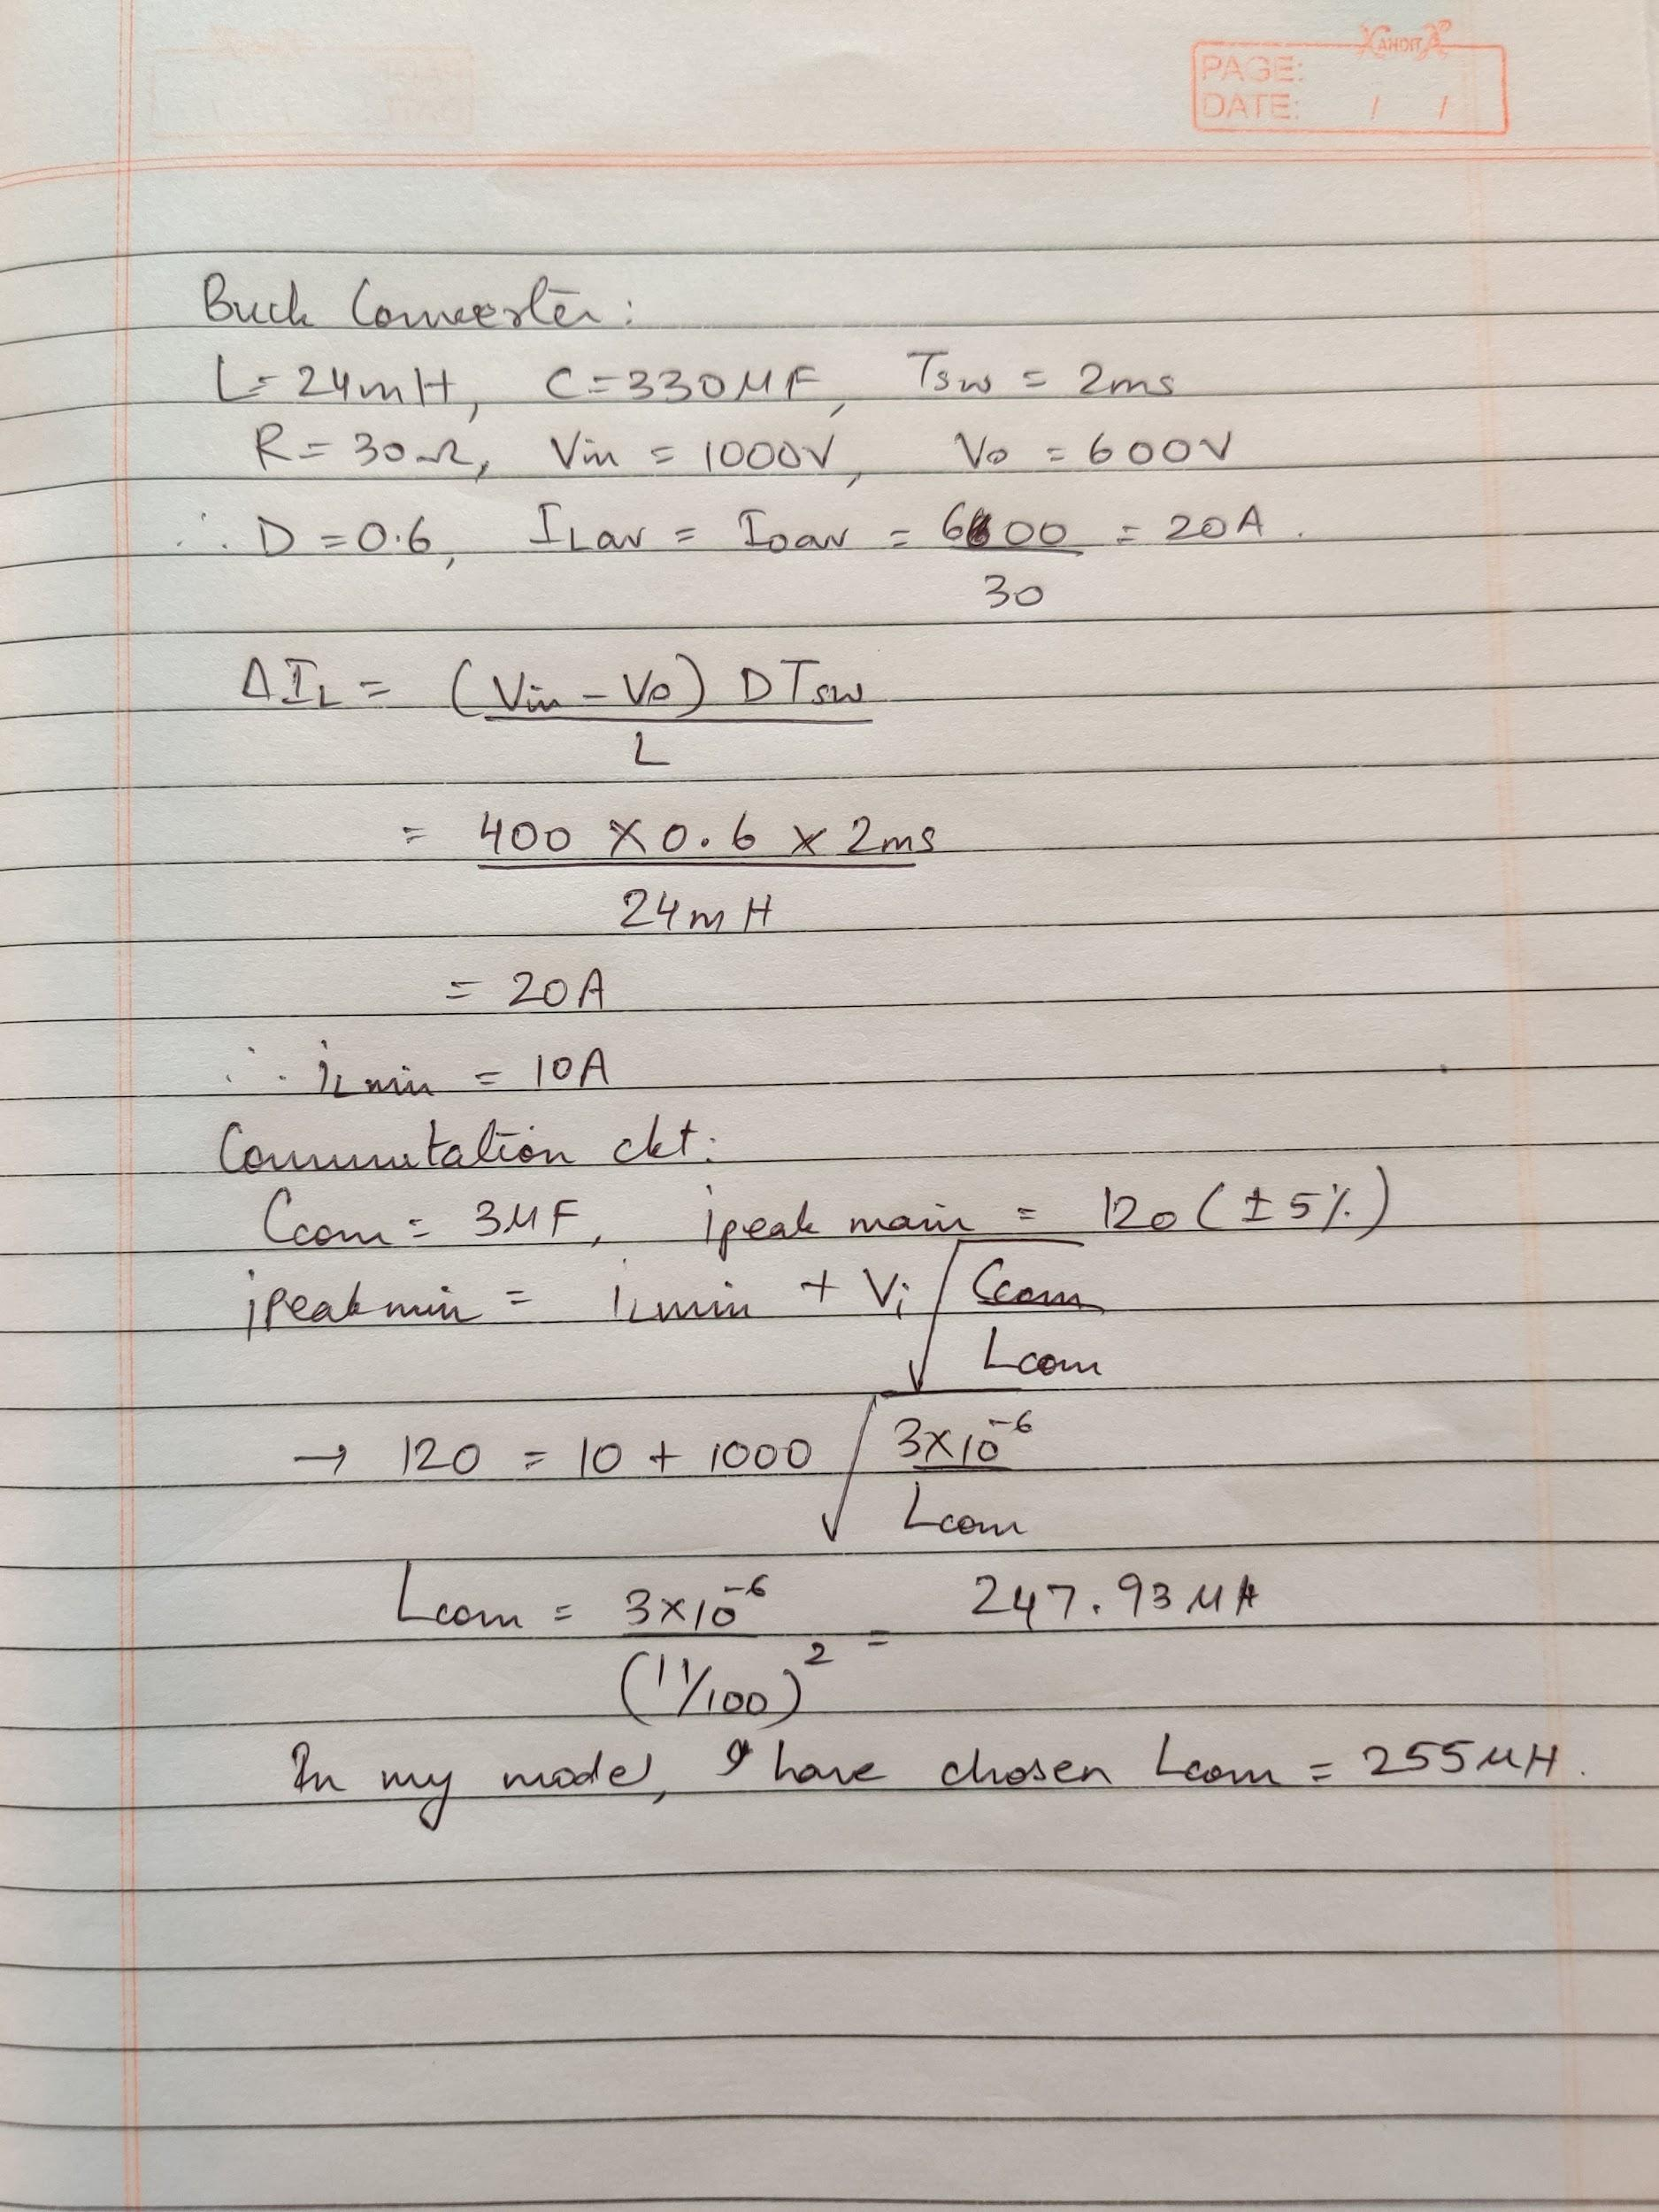

(2)(i) Manipulated turn on time for 600V output voltage = 0.45 (duty ratio) x 2ms (switching period) = 0.9ms

(2)(ii) Turn off time for Main thyristor = 0.06163 ms

Turn off time for Auxiliary thyristor = 0.049702 ms

(2)(iii)

